Breadth First Search (BFS)
Aim
To implement the Breadth First Search (BFS) algorithm for traversing a graph level by level.
Procedure
- Create the graph.
- Select the starting node.
- Mark the starting node as visited and add it to the queue.
- Remove a node from the queue and visit it.
- Add all unvisited adjacent nodes to the queue.
- Repeat the process until the queue becomes empty.
Output
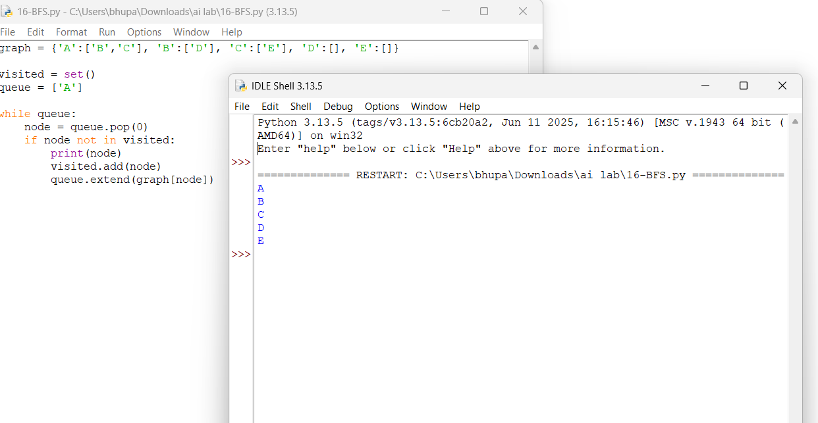Result
The graph was successfully traversed using the Breadth First Search (BFS) algorithm.

